**Gradient Boosting Machine**

**1º corrida**

|  |  |  |  |
| --- | --- | --- | --- |
| **CONTROLES** | **NTREE** | **DEPTH** | **SHRINKAGE** |
| **1** | 500 | 25 | 0.1 |
| **2** | 600 | 30 | 0.01 |
| **3** | 400 | 25 | 0.001 |
| **4** | 500 | 30 | 0.01 |
| **5** | 600 | 25 | 0.01 |
| **6** | 400 | 30 | 0.001 |

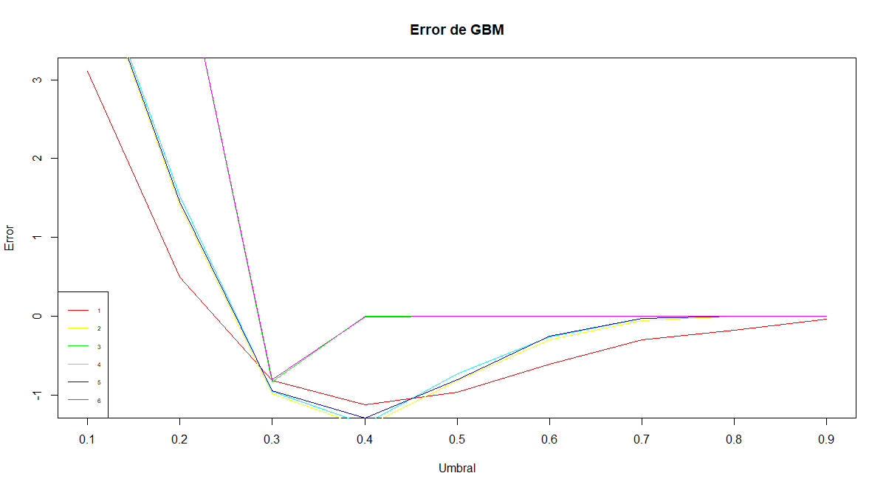

|  |  |  |  |  |  |  |  |  |  |
| --- | --- | --- | --- | --- | --- | --- | --- | --- | --- |
|  | UMBRALES | | | | | | | | |
| **CONTROLES** | **0,1** | **0,2** | **0,3** | **0,4** | **0,5** | **0,6** | **0,7** | **0,8** | **0,9** |
| **1** | 3,106 | 0,498 | -0,816 | -1,118 | -0,967 | -0,605 | -0,302 | -0,172 | -0,041 |
| **2** | 4,688 | 1,407 | -0,979 | **-1,401** | -0,817 | -0,296 | -0,051 | 0,000 | 0,000 |
| **3** | 4,755 | 4,755 | -0,834 | 0,000 | 0,000 | 0,000 | 0,000 | 0,000 | 0,000 |
| **4** | 4,738 | 1,522 | -0,952 | **-1,369** | -0,727 | -0,262 | -0,027 | 0,000 | 0,000 |
| **5** | 4,722 | 1,454 | -0,941 | -1,291 | -0,800 | -0,256 | -0,029 | 0,000 | 0,000 |
| **6** | 4,755 | 4,755 | -0,800 | -0,011 | 0,000 | 0,000 | 0,000 | 0,000 | 0,000 |

**2º corrida**

|  |  |  |  |
| --- | --- | --- | --- |
| **CONTROLES** | **NTREE** | **DEPTH** | **SHRINKAGE** |
| **1** | 600 | 25 | 0.1 |
| **2** | 600 | 25 | 0.01 |
| **3** | 600 | 25 | 0.001 |
| **4** | 600 | 30 | 0.1 |
| **5** | 600 | 30 | 0.01 |
| **6** | 600 | 30 | 0.001 |

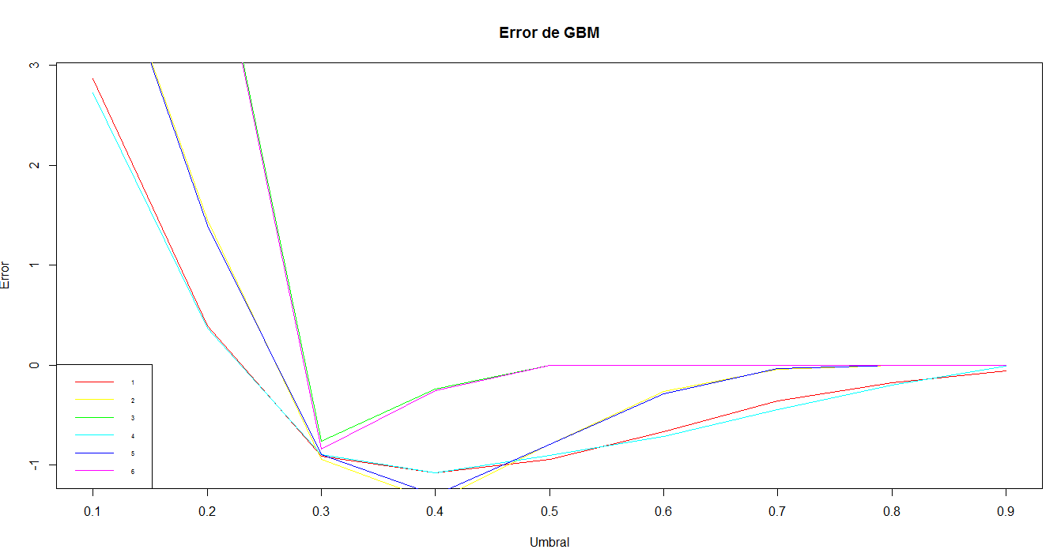

|  |  |  |  |  |  |  |  |  |  |
| --- | --- | --- | --- | --- | --- | --- | --- | --- | --- |
|  | UMBRALES | | | | | | | | |
| **CONTROLES** | **0,1** | **0,2** | **0,3** | **0,4** | **0,5** | **0,6** | **0,7** | **0,8** | **0,9** |
| **1** | 2,868 | 0,397 | -0,914 | -1,076 | -0,941 | -0,666 | -0,360 | -0,176 | -0,060 |
| **2** | 4,708 | 1,451 | -0,947 | **-1,361** | -0,798 | -0,263 | -0,044 | 0,000 | 0,000 |
| **3** | 4,755 | 4,755 | -0,762 | -0,240 | 0,000 | 0,000 | 0,000 | 0,000 | 0,000 |
| **4** | 2,724 | 0,366 | -0,898 | -1,082 | -0,901 | -0,719 | -0,446 | -0,201 | -0,013 |
| **5** | 4,696 | 1,398 | -0,899 | **-1,297** | -0,792 | -0,289 | -0,035 | 0,000 | 0,000 |
| **6** | 4,755 | 4,755 | -0,844 | -0,257 | 0,000 | 0,000 | 0,000 | 0,000 | 0,000 |

**3º corrida**

|  |  |  |  |
| --- | --- | --- | --- |
| **CONTROLES** | **NTREE** | **DEPTH** | **SHRINKAGE** |
| **1** | 600 | 20 | 0.01 |
| **2** | 650 | 20 | 0.01 |
| **3** | 600 | 25 | 0.01 |
| **4** | 650 | 25 | 0.01 |

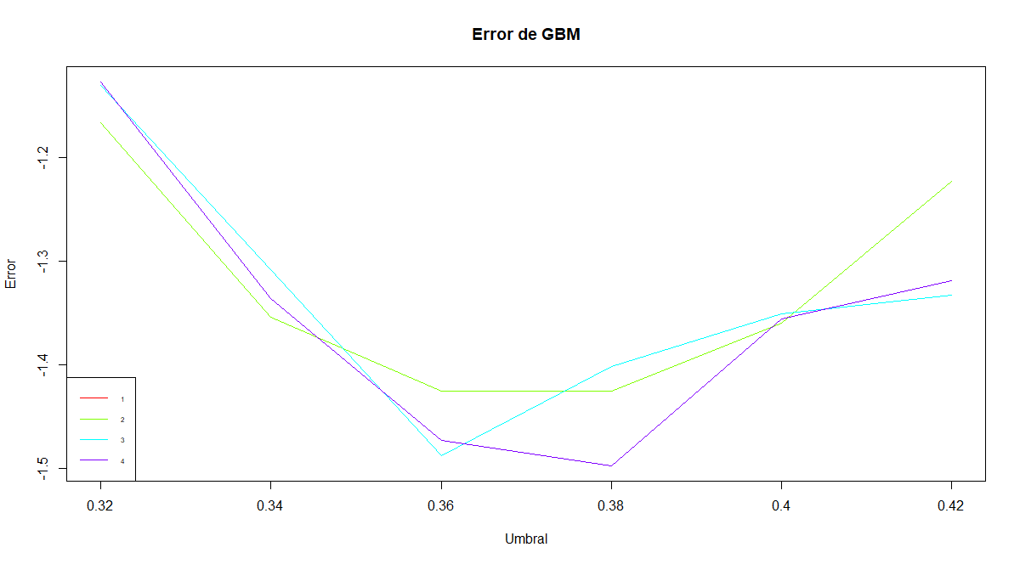

|  |  |  |  |  |  |  |
| --- | --- | --- | --- | --- | --- | --- |
|  | **UMBRALES** | | | | | |
| **CONTROLES** | **0,32** | **0,34** | **0,36** | **0,38** | **0,4** | **0,42** |
| **1** | -1,098 | -1,307 | -1,404 | -1,431 | -1,343 | -1,250 |
| **2** | -1,166 | -1,354 | -1,426 | -1,425 | -1,360 | -1,223 |
| **3** | -1,130 | -1,308 | **-1,488** | -1,402 | -1,351 | -1,332 |
| **4** | -1,127 | -1,336 | -1,473 | **-1,497** | -1,356 | -1,319 |

[[3]]

A gradient boosted model with bernoulli loss function.

600 iterations were performed.

There were 55 predictors of which 55 had non-zero influence.

[[4]]

A gradient boosted model with bernoulli loss function.

650 iterations were performed.

There were 55 predictors of which 55 had non-zero influence.

Se realiza CrossValidation para los Control y Umbral de probabilidad que dieron error más bajo con la función de costo.

Error h1 - umbral: 0.36 test: -1.488362 cv: -1.312191

Error h2 - umbral: 0.38 test: -1.497437 cv: -1.253705

Se sube a kaggle h1 obteniendose score de 1.33752

**4º corrida**

|  |  |  |  |
| --- | --- | --- | --- |
| **CONTROLES** | **NTREE** | **DEPTH** | **SHRINKAGE** |
| **1** | 600 | 20 | 0.01 |
| **2** | 600 | 25 | 0.01 |
| **3** | 600 | 30 | 0.01 |
| **4** | 625 | 20 | 0.01 |
| **5** | 625 | 25 | 0.01 |
| **6** | 625 | 30 | 0.01 |
| **7** | 650 | 20 | 0.01 |
| **8** | 650 | 25 | 0.01 |
| **9** | 650 | 30 | 0.01 |
| **10** | 675 | 20 | 0.01 |
| **11** | 675 | 25 | 0.01 |
| **12** | 675 | 30 | 0.01 |

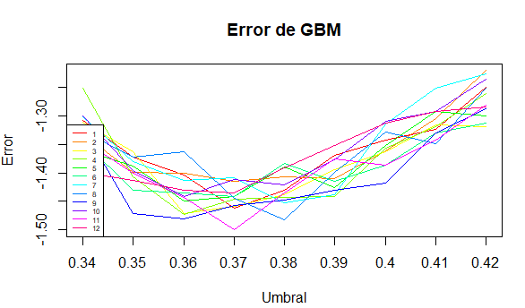

|  |  |  |  |  |  |  |  |  |  |
| --- | --- | --- | --- | --- | --- | --- | --- | --- | --- |
|  | **UMBRALES** | | | | | | | | |
| **CONTROLES** | **0,34** | **0,35** | **0,36** | **0,37** | **0,38** | **0,39** | **0,4** | **0,41** | **0,42** |
| **1** | -1,30739 | -1,37145 | -1,404015 | -1,46274 | -1,43071 | -1,36878 | -1,34262 | -1,3234 | -1,2497 |
| **2** | -1,33088 | -1,39868 | -1,400811 | -1,41523 | -1,40722 | -1,4094 | -1,36077 | -1,30365 | -1,2198 |
| **3** | -1,31113 | -1,362908 | -1,471279 | -1,45847 | -1,43871 | -1,39441 | -1,36291 | -1,3154 | -1,3191 |
| **4** | -1,25027 | -1,406684 | -1,473414 | -1,44619 | -1,44245 | -1,44192 | -1,3565 | -1,31807 | -1,2604 |
| **5** | -1,36024 | -1,387465 | -1,448858 | -1,44085 | -1,3896 | -1,42644 | -1,35116 | -1,29244 | -1,2994 |
| **6** | -1,34316 | -1,430707 | -1,435511 | -1,44138 | -1,38373 | -1,41523 | -1,3864 | -1,32928 | -1,3127 |
| **7** | -1,30205 | -1,380525 | -1,413624 | -1,40829 | -1,45259 | -1,43818 | -1,3138 | -1,25134 | -1,2257 |
| **8** | -1,32714 | -1,371984 | -1,363442 | -1,44459 | -1,48249 | -1,39921 | -1,32874 | -1,34796 | -1,2503 |
| **9** | -1,32074 | -1,471813 | -1,480354 | -1,45740 | -1,44726 | -1,43071 | -1,41736 | -1,32928 | -1,2866 |
| **10** | -1,30045 | -1,396007 | -1,441918 | -1,41202 | -1,42056 | -1,37626 | -1,30952 | -1,29191 | -1,2353 |
| **11** | -1,34209 | -1,400811 | -1,443519 | -1,50064 | -1,43605 | -1,37519 | -1,38586 | -1,34209 | -1,2812 |
| **12** | -1,39868 | -1,413624 | -1,430173 | -1,43551 | -1,3912 | -1,35116 | -1,31219 | -1,29244 | -1,2839 |

Error h1 - umbral: 0.37 test: -1.462737 cv: -1.283749

Error h2 - umbral: 0.37 test: -1.415225 cv: -1.288022

Error h3 - umbral: 0.36 test: -1.471279 cv: -1.306316

Error h4 - umbral: 0.36 test: -1.473414 cv: -1.329684

Error h5 - umbral: 0.36 test: -1.448858 cv: -1.320203

Error h6 - umbral: 0.37 test: -1.441384 cv: -1.307384

Error h7 - umbral: 0.38 test: -1.452594 cv: -1.298571

Error h8 - umbral: 0.38 test: -1.482490 cv: -1.294966

Error h9 - umbral: 0.36 test: -1.480354 cv: -1.307651

Error h10 - umbral: 0.36 test: -1.441918 cv: -1.337962

Error h11 - umbral: 0.37 test: -1.500641 cv: -1.272132

Error h12 - umbral: 0.37 test: -1.435511 cv: -1.304046

Se sube a kaggle h10 obteniendose score de 1.3047

Se sube a kaggle h4 obteniendose score de 1.23687